CHARTS

Charts allow you to present your information graphically. Report Studio offers 12 groups of charts with multiple configurations for each group. To see the chart types, you can open the New report box in Report Studio and select Chart.

A. Look at the various chart groups/ types (start with UD Financial Data Mart):

- Select Create a new report or template
- New window – select Chart

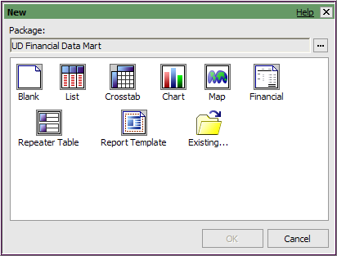

- Choose a Chart group on the left side
- Choose a Chart type on the right side
- The Information panel displays a description and usage details for that specific group/type combination.

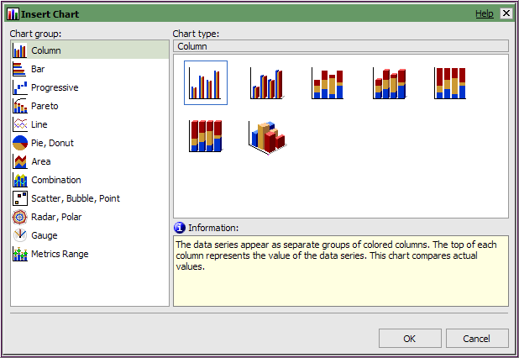
B. Create a Pie Chart for a Purpose’s current fiscal year expenses

- Open Report Studio using UD Financial Data Mart
- Click Create a new report or template
- Double-click the Chart icon 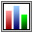
- In Chart Group panel, choose Pie, Donut
- In the Chart type, choose a Pie or Pie with 3-D and click OK

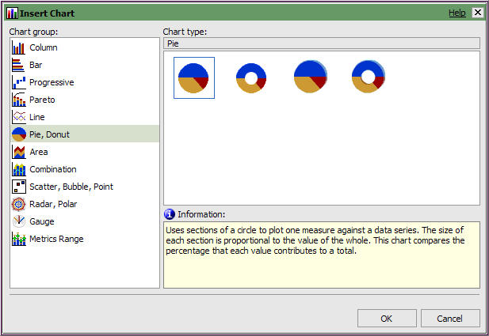

- The work area shows your chart type and three data elements you’ll add:
  - Default measure – transactions amount
  - Pie Slices – Account and Account description
  - Pies – fiscal year

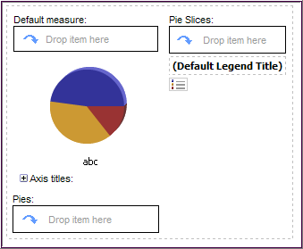

- Open UD Financial Data Mart and add the following fields to the chart
- Default measure, drag and drop:

Field Name | Query Subject | Folder
TRANS_AMOUNT | Trans Detail

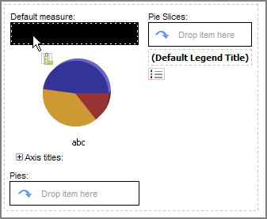
Drop TRANS_AMT here

- Pie Slices, drag and drop:

Field Name | Query Subject | Folder
ACCOUNT | Chart of Accounts | Account
ACCOUNT_DESCR | Chart of Accounts | Account

1st 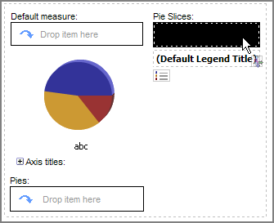 2nd 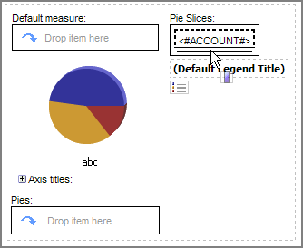
Look for thin, blinking line under ACCOUNT and drop ACCOUNT_DESCR here
Drop ACCOUNT here

3rd 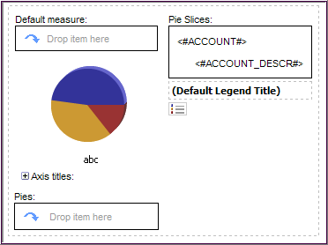
Pie Slices should look like this
- Pies, drag and drop:

Field Name | Query Subject | Folder
FISCAL_YEAR | Trans Detail | Dates

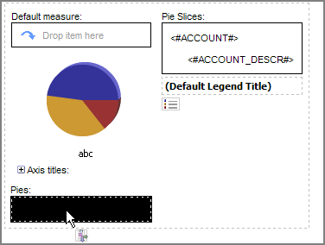
Drop FISCAL_YEAR here

- Save this report in My Folders and name it Pie Chart Curr FY Trans

- Click on <#ACCOUNT#> and Sort Ascending

- Click the chart area and add the following three filters from the pre-written Filters folder:
  - ACTUALS Ledger Filter
  - Current Fiscal Year Filter
  - Journal ID not blank Filter
  - Statistics Code not ENP ENU Filter

- Add the following prompt from the pre-written Prompts folder:
  - Purpose Prompt

- Your work area should look like this:

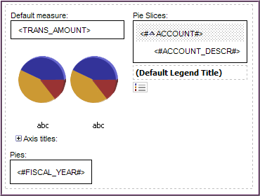

- Save your work

- Run the report with one Purpose code

To enhance the readability of the pie chart, we’ll make some formatting changes.

- Add a dynamic title for the Purpose
  - In the Insertable Objects pane, click Toolbox
  - Click Block and drag to title area, release when black dotted line surrounds the title area

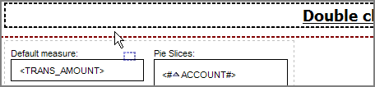

  - Click Layout Calculation and drag it into the block
  - In the Report Expression window, click the Parameters tab
  - Double-click Select Purpose and click OK

- Change the label for the Pie(s):
  - In the Pies box, click the box around <#FISCAL_YEAR#>
  - Make sure Properties says Pies (use the Ancestor button if needed)
  - In Properties, go to Data Item/Label
  - Type in Fiscal Year

- Change the title for the legend
  - Under the Pie Slices box, double-click where it says (Default Legend Title)
  - A warning message pops up – “This selection does not have a default action.” Click OK
  - The text in the box changes to “Double click to edit the text”
  - Double-click the new text
  - In the Text box type: Accounts and click OK

- Change the legend to display entire Account Description
  - Click the legend box in the work area

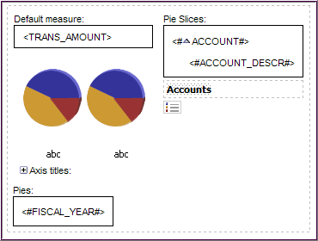

  - In Properties (it should say “Legend”)
  - Go to General/Auto Truncation
  - Change to No

- Add a percentage value to the pie slices
  - Click on the chart
  - In Properties (it should say “Pie Chart”)
    - Go to Chart Labels
    - Click Values and change to Outside slices with lines
    - Click Tooltips and change to Show
    - Click Value Representation and change to Percent

- Save your work

- Run the report

- Change the chart to grey scale or patterns (in case it will be printed b&w)
  - Click on the chart
  - In Properties, go to Color & Background
  - Select Palette and click the ellipses
  - In the Palette window, click the Palette dropdown

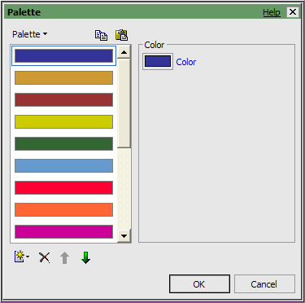

  - Choose either Patterns or Grey Scale
  - Click OK

- Save your work

- Run the report
  - Hover your mouse pointer over the pie slices to see the additional info

C. Add a Column Chart to a Crosstab report

- New (we will use the UD Financial Data Mart package) and select Crosstab

- Add this field to the Rows:

Field Name | Query Subject | Folder
FISCAL_YEAR | Balances | Dates

- Add these fields to the Columns:

Field Name | Query Subject | Folder
CHARTFIELD1 | Balances
ACCOUNTING_PERIOD | Balances | Dates

- Add this field to the Measures:

Field Name | Query Subject | Folder
AVAILABLE_BALANCE | Balances

- Sort CHARTFIELD1 Ascending

- Sort ACCOUNTING_PERIOD Ascending

- Your work area should look like this:

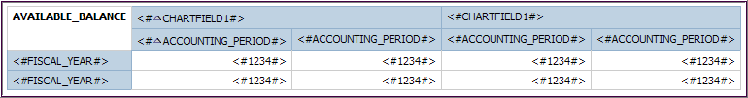

- Add the following pre-written prompt from the Prompt folder:
  - Purpose Prompt

- Add the following filters with the Filter button and Add button:

  - [FISCAL_YEAR] in (2009,2010)

    - Validate the expression before clicking OK

  - [ACCOUNTING_PERIOD] in (1, 2, 3, 4, 5, 6)

- Validate the expression before clicking OK

- Save the report in My Folders and name it Column Chart Crosstab

- Run the report and review the data

Next we’ll add a column chart to the crosstab report:
- Click the Insert Chart button from the toolbar

- Accept the default Chart group and type (a basic column graph) and click OK

- Your work area should look like this:

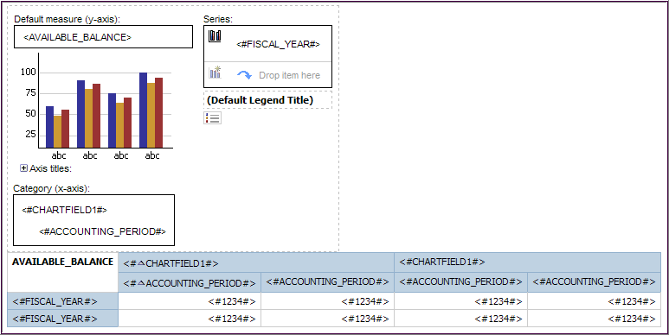

- In the Column Chart, Sort the following fields Ascending:
  - Series: <#FISCAL_YEAR#>
  - Category: <#CHARTFIELD1#>
  - Category: <#ACCOUNTING_PERIOD#>

- Save your work

- Run the report

To enhance the readability of the column chart, we’ll make some formatting changes.

- Add some space between the chart and the crosstab
  - Click the Toolbox tab
  - Drag and drop a Block next to the chart when you see the thick black blinking line

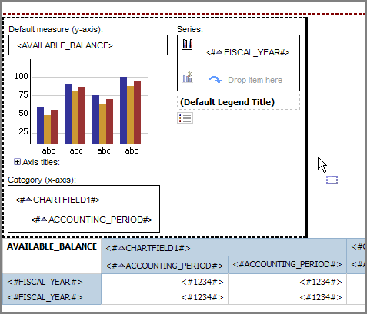

  - Drag and drop a Text Item into the block

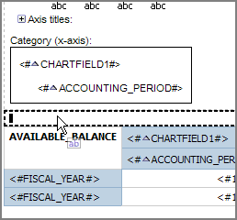

  - Type [space] [space] in the Text window
  - In the work area, click the block and choose the Font size of 16 pt

- Change the colors of the column bars to make them better “UD” colors (or not)
  - Click the chart in the work area
  - In Properties, go to Color & Background/Palette, click Ellipses
  - In the Palette window the colors for the columns will be used in the order displayed.

(Note - There are only two years in our chart, so we’re only concerned with the top two colors.)
  - Find the “bright blue” color and move it up to the top with the Up arrow
  - Find the “bright gold” color and move it up to second from the top position with the Up arrow
  - Click OK

- Turn on Tooltips for the chart
  - In Properties, go to Chart Labels/Tooltips and change to Show

- Save your work

- Run the report
Note: Hover your mouse over the columns in the chart to see the additional information

D. Convert a chart to a different type (using the chart from C. above)

- In the menu File/Save As… save the report with a new name, Convert Chart Crosstab
- In the work area, right click on the chart and choose Convert Chart…
- Experiment with different chart groups/types
  - Line
  - Bar
  - Pareto

- Run the report after each new chart to see how you like the results.

- Save the report when you are done trying out different charts.

