Cognos Training – Level II - Advanced Topics

JOINS
In Report Studio, data can be incorporated from multiple queries to create more complex reports. You will use Query Explorer to build/manage the queries and join them to create the relationship between the queries. Keep these items in mind when using joins:

- Joins can only be used within the same package
- A query must be created for the report layout (results) as well as for the data queries
- The report can be started with a List, Crosstab, Chart or Blank report type

A. Simple example of a join, starting with a LIST

You will create a report using transaction data from two different fiscal years by creating two data queries and one report layout query.

- Open Report Studio using UD Financial Data Mart (in FDM packages)

- Click Create a new report or template
- Double-click the List icon

- Click Query Explorer on the Explorer Bar (click Yes on the pop-up)

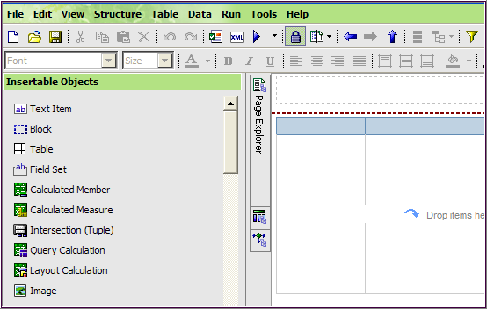
Query Explorer

- Click Queries

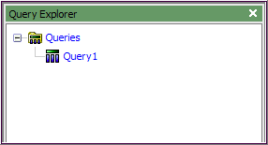

- From the Toolbox, drag & drop two additional Queries to the work area.

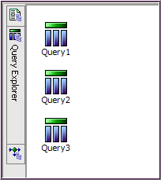

- Rename the three Queries (this will make working with them easier)
  - Click on Query1
    - Go to Properties, scroll to Miscellaneous/Name (at the bottom)
    - Change name to Report

  - Click on Query2
    - Change name to Trans FY 2008

  - Click on Query3
    - Change name to Trans FY 2009

- From Insertable Objects, drag & droop a Join next to the Report query,

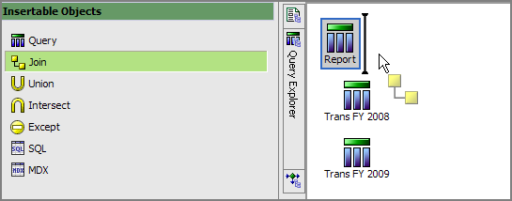

- It will look like this:

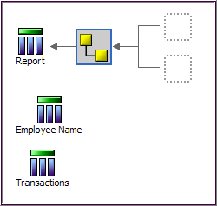

- Save your report and name it Join Trans 2FY Totals
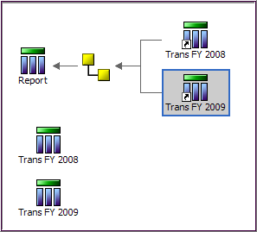

- Drag the Trans FY 2008 query to the top box

- Drag the Trans FY 2009 query to the bottom box.

- Double-click the Trans FY 2008 query, this will open the data window

- Drag these 4 fields from UD Financial Data Mart/Insertable Objects

Field Name | Query Subject | Folder
PURPOSE | Chart of Accounts | Purpose
ACCOUNT | Chart of Accounts | Account
TRANS_AMOUNT | Trans Detail
FISCAL_YEAR | Trans Detail | Dates

…to the Data Items pane:

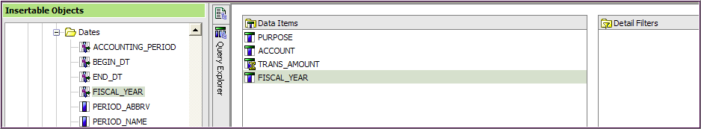

- Add these two Filters and validate each one:
  - [FISCAL_YEAR]=2008

  - [PURPOSE]='TREA112112' - use one of your own Purpose codes

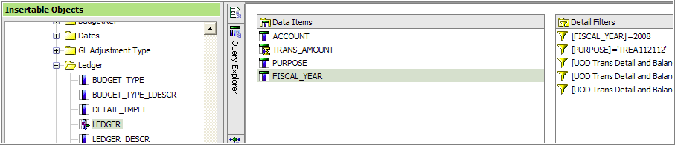

- Add these three pre-written Filters:
  - ACTUALS Ledger Filter
  - Journal ID not blank Filter
  - Statistics Code not ENP ENU Filter

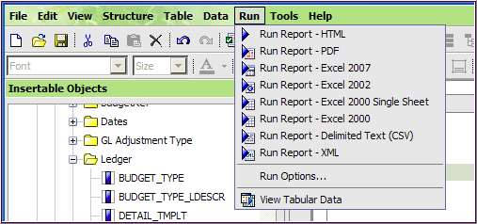

- Click the Run menu item and choose

- View Tabular Data to verify data is good

- Jot down the number of Accounts

- Save your work

- Open Query Explorer and click Trans FY 2009 query

- Add the same 4 fields from UD Financial Data Mart to Data Items:

Field Name | Query Subject | Folder
PURPOSE | Chart of Accounts | Purpose
ACCOUNT | Chart of Accounts | Account
TRANS_AMOUNT | Trans Detail
FISCAL_YEAR | Trans Detail | Dates

- Add these two Filters and validate each one
- [FISCAL_YEAR]=2009

- [PURPOSE]='TREA112112' - use one of your own Purposes codes

- Add these three pre-written Filters:
- ACTUALS Ledger Filter
- Journal ID not blank Filter
- Statistics Code not ENP ENU Filter

- Click the Run menu item and View Tabular Data to verify data is good
  - Again, jot down the number of Accounts

- Save your work

- Click Query Explorer, click Queries

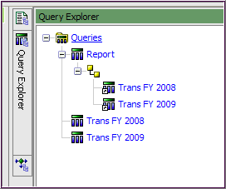
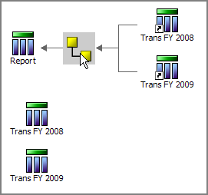
- Double-click the Join

- In the Join Relationship window, click the New Link button

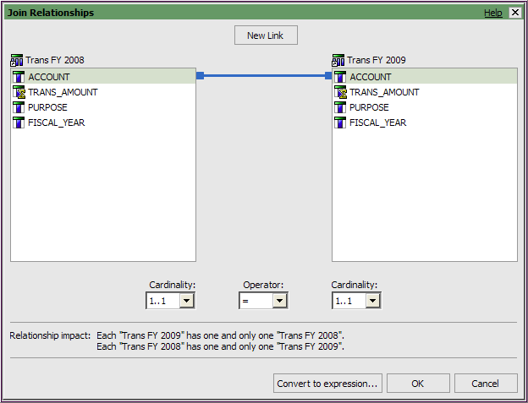

- The join should be between Account and Account
- Change the join by clicking on a field name on either side

- Set the Cardinality to 1..1 = 1..1 and click OK

(There is one-to-one relationship between the two queries with regards to ACCOUNT and each ACCOUNT will be in each query only once.)
When setting the Cardinality for a join, consider the relationship between the fields:

- 1..n – the relationship is one to many
- 1..1- the relationship is a one to one
- 0..n – the relationship is zero (or more) to many
- 0..1 – the relationship is zero (or one) to one
- Never use the Cardinality 1..n = 1..n – it is illogical.

The Relationship impact explanation changes based on your selections and can guide you when deciding how to set the Cardinality.

.

- Save your work

- While still in Query Explorer, double-click the Report query
  - You must first add fields to the Report query before the fields will be available for the report’s layout (the List in this case).
- From Trans FY 2008, drag all the fields to the Data Items pane

- And drag all the fields from Trans FY 2009

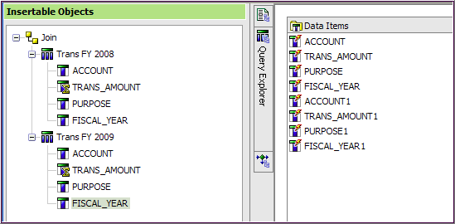
FY08
FY09
Notice the data item icons all have “lightening bolts” to indicate they are derived from other queries.

- Click Page Explorer, and then Page 1

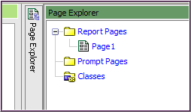

The List is empty; you must add the fields you want.

- Click Data Items tab and double-click these 3 fields from the Report query:

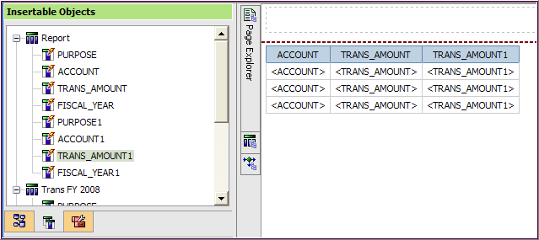
FY09
FY08
You can only use “lightening bolts” data fields in your report layout!
Change the Trans Amount column headings to something more meaningful.

- Click column heading called TRANS_AMOUNT
- Go to Properties
- Data Item/Label – change to FY08 Total

- Click column heading called TRANS_AMOUNT1
- Go to Properties
- Data Item/Label – change to FY09 Total

Add totals to the renamed TRANS_AMOUNT columns

- Click the FY08 Total column heading and click Aggregate and Total

- Click the FY09 Total column heading and click Aggregate and Total

- The List should look like this:

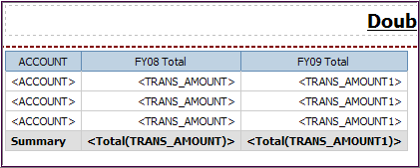

- Save your work

- Run the report

Fix the report to include the Accounts not included in BOTH queries!

- Click Query Explorer, Queries and click Join
- Change the Cardinality to 0..1 = 0..1
- Click OK

- Click Page Explorer and click Page 1
- Click the tab
- Click and drag ACCOUNT1 to the work area as shown below:

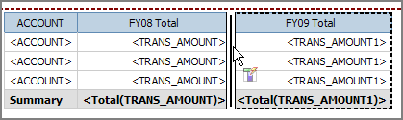

- Save your work

- Run the report (it could take up to 5-7 minutes)

Add a column to show the percentage difference between FY2008 and FY 2009, this is the math: (FY09 – FY08) / FY08 (Query Calculation)

- Click the Toolbox tab
- Click and drag a Query Calculation to right of the last column (look for the thin, blinking line)

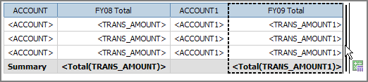

- Name it % Diff FY08 to FY09 and click OK
- Add this expression using the fields in the Available Components

([Trans FY 2009].[TRANS_AMOUNT]-[Trans FY 008].[TRANS_AMOUNT])/[Trans FY 2008].[TRANS_AMOUNT]

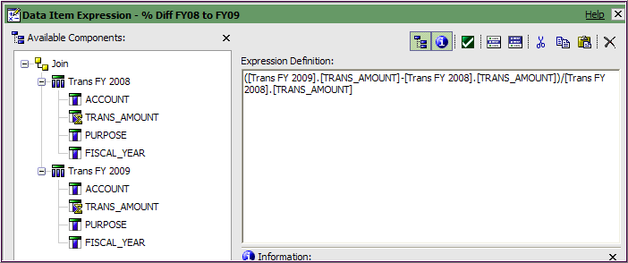
(2), (3)
(1)
You must add:
(
-
)/

- Validate the expression
- Click OK

- Click the column body where it says <%Diff FY08 to FY09> and Properties
- Click Data/Data Format – click the ellipses
- Format type – select Percent
- Properties/No. of Decimal Places – select 1
- Click OK

- Save your work

- Run the report

Other Possible Enhancements to Join A (Join Trans 2FY Totals)

Add Account Description to the report

- Query Explorer, click on Trans FY 2008 query
- From Insertable Objects, open Chart of Accounts and Account
- Drag ACCOUNT_DESCR to the Data Items pane (under FISCAL_YEAR)

- Query Explorer, click on Trans FY 2009 query
- From Insertable Objects (Account should already be open)
- Drag ACCOUNT_DESCR to the Data Items pane (under FISCAL_YEAR)

- Query Explorer, click on Report query
- Drag ACCOUNT_DESCR (from FY08)to the Data Items (to bottom of list)
- Drag ACCOUNT_DESCR (from FY09)to the Data Items (to bottom of list)

- Page Explorer, click Page1
- Click Data Items tab

- Drag ACCOUNT_DESCR (from FY08) to work area between ACCOUNT and FY08 Total

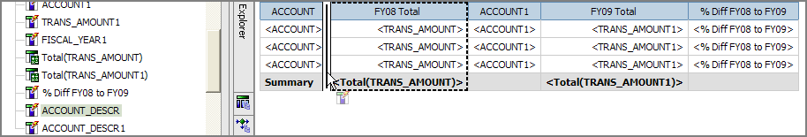

- Drag ACCOUNT_DESCR1 (from FY09) to work area between ACCOUNT and FY09 Total

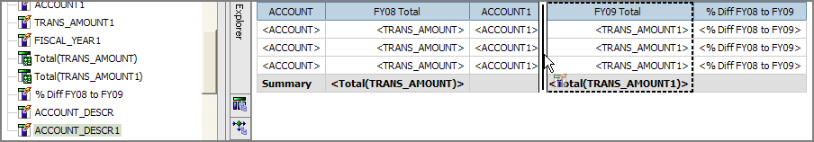

- Save
- Run the report

Add a separate List report to verify your data

- Click the Toolbox tab
  - Click a List
  - Drag it under the existing list (look for thick, black line)

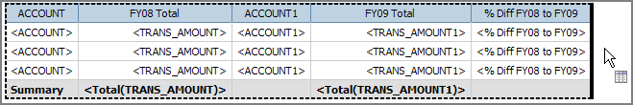

- Your work area should look like this:

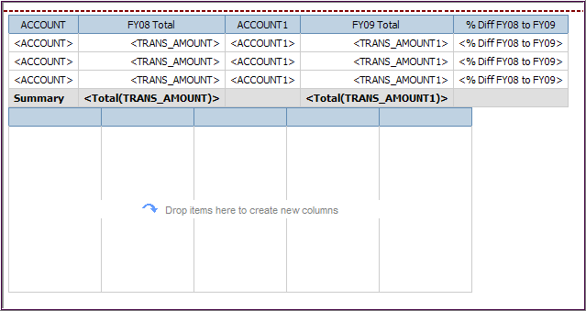

- Click Source tab
- Add these fields: PURPOSE, ACCOUNT, and TRANS_AMOUNT
- Add this Filter and Validate it:
  - [PURPOSE]='TREA112112' - use the same Purposes code as above

- Add these three pre-written Filters:
- ACTUALS Ledger Filter
- Journal ID not blank Filter
- Statistics Code not ENP ENU Filter

- Click TRANS_AMOUNT column heading
  - Click Aggregate and click Total

- Add pre-written prompt Fiscal Year Prompt

- Click the Toolbox tab to add a dynamic field for the FY value
  - Drag a Layout Calculation to the new list
  - Make it the 4th column

- In the Report Expression, click the Parameters tab
  - Drag the fiscal year prompt to the expression box and
  - Validate and click OK

- Save

- Run the report
B. Another join with different data queries

You will create a report that returns chartfield and row security (viewers/approvers) information for a specific Speedtype. (Based on EZQ_DV_SPEEDTPYE)

- Open Report Studio using UD Financial Data Mart

- Click Create a new report or template
- Double-click the List icon

- Click Query Explorer on the Explorer Bar

- Click Queries

- From Insertable Objects, drag two additional Queries to the work area.

- Rename the three Queries (this will make working with them easier)
- Go to Properties, scroll to Miscellaneous/Name (at the bottom)
    - Click on Query1; change name to Joined Data
    - Click on Query2; change name to Speedtype
    - Click on Query3; change name to Row Security

- From Insertable Objects, drag a Join next to the Joined Data query

- Save your report and name it Join Speedtype and Row Security

- Drag the Speedtype query to the top box

- Drag the Row Security query to the bottom box.

- Double-click the Speedtype query, this will open the data window

- Drag the following 11 fields from UD Financial Data Mart to the Data Items pane:

Field Name | Query Subject | Folder
SPEEDTYPE_KEY | Chart of Accounts | Speedtype
DESCR | Chart of Accounts | Speedtype
Speedtype CHARTFIELD1 (Purpose) | Chart of Accounts | Speedtype
PURPOSE_DESCR | Chart of Accounts | Purpose
PURPOSE_EFF_STATUS | Chart of Accounts | Purpose
DEPTID1 | Chart of Accounts | Speedtype
PROGRAM_CODE1 | Chart of Accounts | Speedtype
FUND_CODE1 | Chart of Accounts | Speedtype
Speedtype CHARTFIELD2 | Chart of Accounts | Speedtype
PROJECT_ID1 | Chart of Accounts | Speedtype
PROJECT_DESCR | Chart of Accounts | Project

- Add one Filter and validate it
  - This is a temporary filter to test the query:
  - [SPEEDTYPE_KEY]='CHEM322239' (you may use your own Speedtype or this one)

- Click the Run menu item and choose View Tabular Data to verify data is good

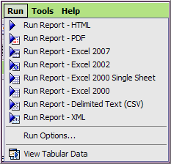
Note - If you get a pop-message saying it can’t be run, click any field in Data Items and try again.

- Save your work

- Open Query Explorer and click Row Security query

- Add these three fields from UD Financial Data Mart to the Data Items pane:

Field Name | Query Subject | Folder
Row Level CHARTFIELD1 | FIN Row Security
Operator ID Descr (name of person) | FIN Row Security
Row Level Approver/Viewer Flag | FIN Row Security

- Add one Filter and validate it
  - This is a temporary filter to test the query:
  - [Row Level CHARTFIELD1]='CHEM322239' (use the same Speedtype as above)

- Click the Run menu item and View Tabular Data to verify data is good

(The values in Row Level Approver/Viewer Flag are Y and N – we’ll improve this later.)

- Disable the temporary filters for CHEM322239 on both queries
  - Row Security query is open, click on the filter in the Detail Filters pane
    - Go to Properties
    - Click General/Usage and change Required to Disabled

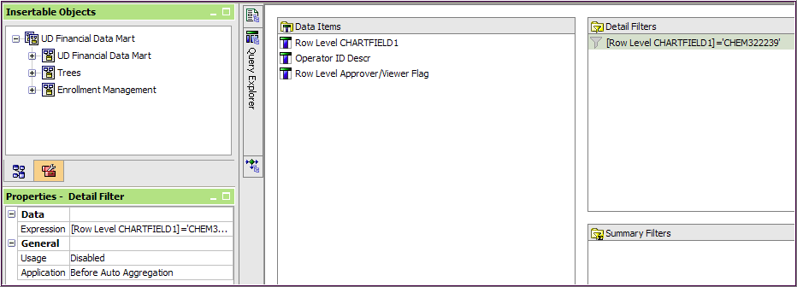
  - Open Query Explorer and click the Speedtype query
    - Click on the filter in the Detail Filters pane
    - Go to Properties
    - Click General/Usage and change Required to Disabled

- Add the pre-written Purpose Prompt to both queries
  - With Speedtype query open, click the Source tab in Insertable Objects
    - Open the Prompts folder
    - Drag & drop the Purpose Prompt to the Detail Filters pane

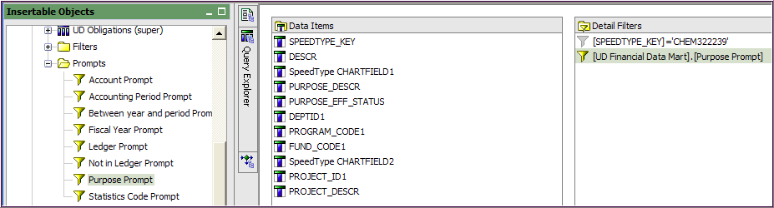

  - Open Query Explorer and click the Row Security query
    - Drag & drop the Purpose Prompt to the Detail Filters pane

- Click Query Explorer, click Queries

- Double-click the Join

- In the Join Relationship window, click the New Link button

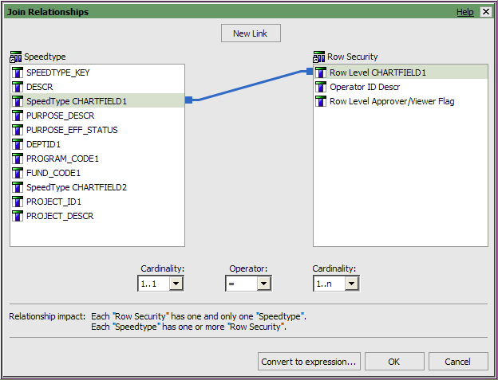
There is one Speedtype for each Chartfield1 (Purpose)
There are potentially many approvers/viewers for every Chartfield1 (Purpose)

a. The join is between: Speedtype CHARTFIELD1 and Row Level CHARTFIELD1
b. Set the Cardinality to 1..1 = 1..n and click OK
- Save your work

- Open Query Explorer, double-click the Joined Data query
- You must first add fields to the Joined Data query before the fields will be available for the report’s layout (the List in this case).

- From Speedtype, drag all the fields to the Data Items pane

- And from Row Security, drag all the fields to the Data Items pane

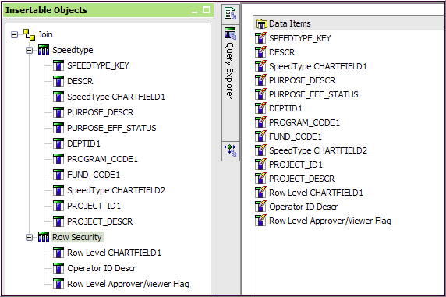

- Click Page Explorer, and then click Page 1

The List is empty; you must add the fields you want.

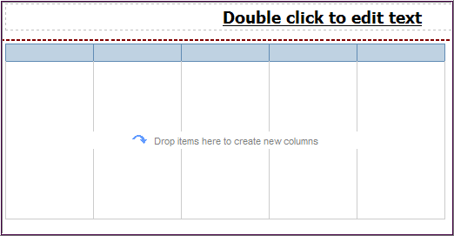

- Click the Data Items tab and add all the fields from the Joined Data query (except Row Level CHARTFIELD1 near the bottom – it’s redundant):

Suggestion: click and drag Joined Data to the work area to add all fields and then click the column header for Row Level CHARTFIELD1 and Cut it from the list.

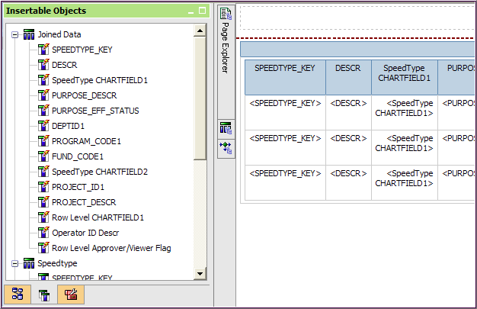
Remember: You can only use “lightening bolts” data fields in your report layout!

- Run the report

- Change Row Level Approver/Viewer Flag values (Y/N) to the words “Approver” and “Viewer”
  - We’ll add a “case when” statement by adding a Data Item Expression (not a Filter!!)
  - In the work area, scroll all the way to the right
  - Double-click the Row Level Approver/Viewer Flag heading
  - A Data Item Expression window pops-up
  - In the expression box enter:

case when [Row Security].[Row Level Approver/Viewer Flag] = 'Y' then 'Approver' when [Row Security].[Row Level Approver/Viewer Flag] = 'N' then 'Viewer'
else ' '
end
Type:
Else single-quote [space bar] single-quote, [return]
end

  - Validate the expression
  - Click OK

- Save your work

- Run the report

Enhancements to the Join Speedtype and Row Security report

►Group the columns to make the report easier to read

- Click SPEEDTYPE_KEY heading, scroll to the right and [Shift]-click PROJECT_DESCR heading to include all the headings in between
- Click the Group/Ungroup button

  - The work area will look like this (partial view):

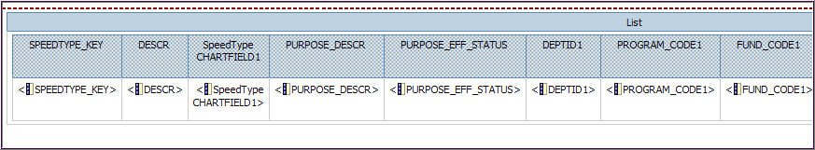

- Save your work
- Run the report

►Display only the most recent Purpose description

- Open Query Explorer and click the Speedtype query
- From the Source tab, open UD Financial Data Mart, then Chart of Accounts and the Purpose folder
- Drag & drop PURPOSE_CURRNT_FLAG to the Detail Filters pane

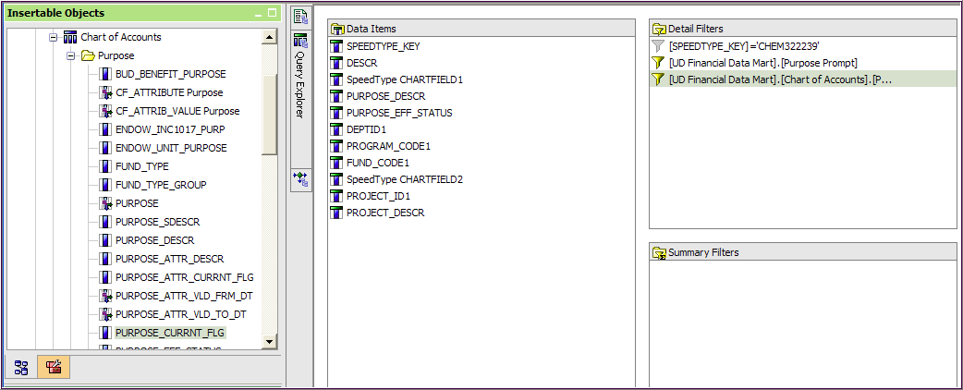
This is all you need to type

- In the expression window, create this expression:

[UD Financial Data Mart].[Chart of Accounts].[PURPOSE_CURRNT_FLG] = 'C'

- Validate and click OK twice
- Save your work
- Run the report
Master-Detail Reports

A Master-Detail report enables you to display information from two data sources in one report that would normally require two reports. This is accomplished by setting up a master detail relationship between two data containers (such as a list and list, or a list and a crosstab). FYI – the two data sources must be from the same package.

In the following exercise, you will create a Master-Detail report with the UD Financial Data package. The master will be a list report created from the Balances query subject and include the Available Balance for one or more Purpose codes as of a certain period in the current fiscal year. And the detail report will be a crosstab with data from the Trans Detail query subject for the same fiscal year.

Create the MASTER report
- Open Report Studio using UD Financial Data Mart (in FDM packages)

- Click Create a new report or template
- Double-click the List icon - this will be the Master for the Balances information

- Open UD Financial Data Mart in Insertable Objects

- Add the following “Balance” fields to the list in this order:

Field Name | Query Subject | Folder
PURPOSE_DESCR | Chart of Accounts | Purpose
FISCAL_YEAR | Balances | Dates
ACCOUNTING_PERIOD | Balances | Dates
UOD_BEG_FISC_BAL | Balances
UOD_NET_BUDGET | Balances
UOD_END_FISCAL_BAL | Balances
AVAILABLE_BALANCE | Balances
CHARTFIELD1 | Balances

- Sort CHARTFIELD1 ascending

- Change the label of two column headings so they will take up less room:
  - Click the heading for FISCAL_YEAR and go to Properties
    - Under Data Item/Label - type FY
  - Click the heading for ACCOUNTING_PERIOD and go to Properties
    - Under Data Item/Label - type Period

- Save the report in My Folders and name it Master Detail

- Set the decimal points to 2 for UOD_NET_BUDGET
  - Click the column body for UOD_NET_BUDGET
  - Go to Properties, under Data/Data Format, click the ellipses
  - Format type – choose Number
  - Properties/No. of Decimal Places – select 2

- Add the following two pre-written prompts:
  - Purpose Prompt
  - Accounting Period Prompt

- Add the following pre-written filter:
  - Current Fiscal Year Filter
- Save and Run the report with multiple Purpose codes
- On the toolbar, click the Unlock button
  - It will look like this
  - Unlocking allows another data container (crosstab) to be embedded into the list

- Next we’ll create the Detail report for the Transaction information
  - On the Toolbox tab, drag a Crosstab into the first data cell in the CHARTFIELD1 column (look for the small, blinking black line)

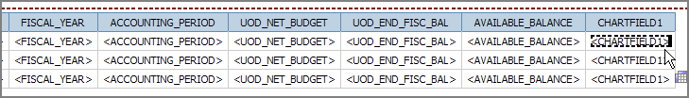

- Scroll to the right and your work area should look like this:

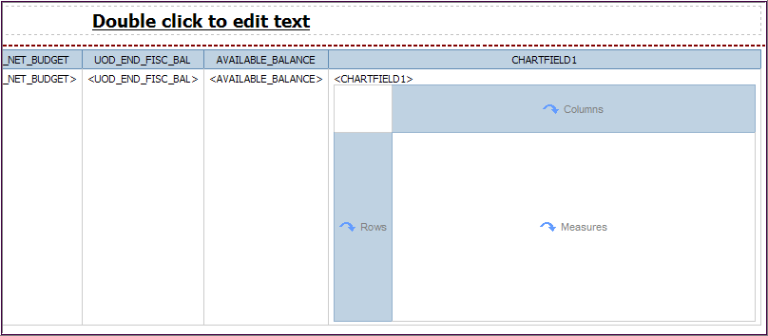

- IMPORTANT - On the toolbar, click the Lock button

- Click the Source tab and add the following “Transaction” fields to the crosstab:
  - Rows:

Field Name | Query Subject | Folder
CHARTFIELD1 | Trans Detail
ACCOUNT | Chart of Accounts | Account
ACCOUNT_DESCR | Chart of Accounts | Account

Drop ACCOUNT when it looks like this:
Drop ACCOUNT_DESCR when it looks like this:
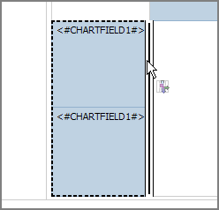

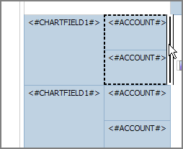

  - Measures:

Field Name | Query Subject | Folder
TRANS_AMOUNT | Trans Detail

  - Columns:

Field Name | Query Subject | Folder
ACCOUNTING_PERIOD | Trans Detail | Dates

Your work area should look like this (partial view):

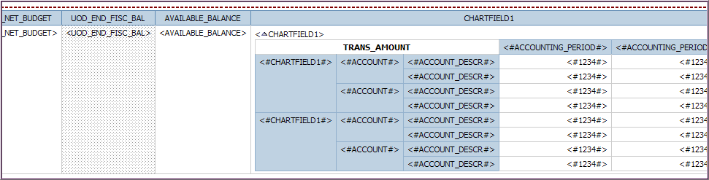

- Click on CHARTFIELD1 in the crosstab and Cut it (do not delete it)

- Save

- Click on the crosstab (anywhere) and add the following pre-written filters:
  - ACTUALS Ledger Filter
  - Current Fiscal Year Filter
  - Journal ID not blank Filter
  - Statistics Code not ENP ENU
  - Note: the pop-up messages should say filters have been added to Query2

- Sort ACCOUNT ascending

- Sort ACCOUNTING_PERIOD ascending

- Click <ACCOUNT#> and then Aggregate , choose Total

- Click <ACCOUNTING_PERIOD#> and then Aggregate , choose Total

- Change the Names for the totals:
  - Click on <#Total(ACCOUNT)#> and go to Properties
  - Under Data Item/Name – type Total by Accounting Period
  - Click on <#Total(ACCOUNTING_PERIOD)#> and go to Properties
  - Under Data Item/Name – type Total by Account

Your crosstab work area should look like this:

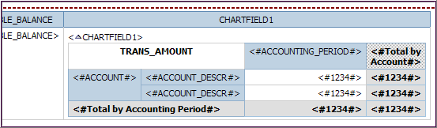
- Save

- You will now create the Master-Detail relationship:
  - Click one of the fields in the crosstab*, such as ACCOUNT
  - On the menu toolbar, click Data and Master Detail Relationships

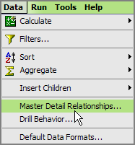
* Note - in a List you would click one of the column headings

  - Click the New Link button
  - Click CHARTFIELD1 in both the Master and the Detail panes
  - Click OK

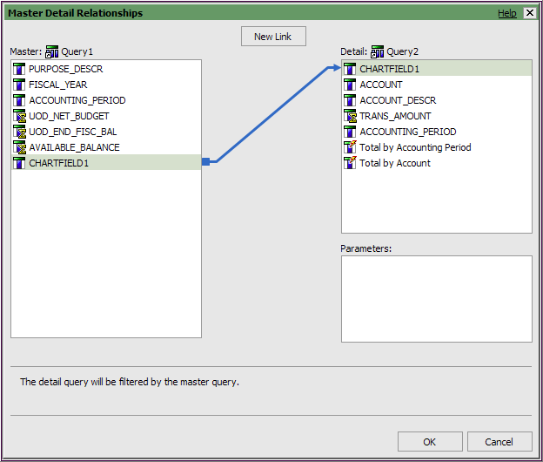

- Save

- Run the report
  - First time, choose these prompt values:
    - Accounting period from current FY (e.g. 10 for April)
    - One Purpose code

  - Second time, choose these prompt values:
    - Accounting period from current FY (e.g. 10 for April)
    - Multiple Purpose codes

BONUS MATERIAL: Master-Detail Report with Drill Through!

In this exercise you will add drill-through capabilities to the report you just created.

- Rename the report created above to be the “Source” for the drill
  - Go to File/Save as and call it AA Master Detail w Drill SOURCE

- Click on New report

- Select List

- Add these fields to the work area:

Field Name | Query Subject | Folder
CHARTFIELD1 | Trans Detail
FISCAL_YEAR | Trans Detail | Dates
ACCOUNTING_PERIOD | Trans Detail | Dates
ACCOUNTING_DT | Trans Detail
ACCOUNT | Chart of Accounts | Account
ACCOUNT_DESCR | Chart of Accounts | Account
JOURNAL_ID | Trans Detail
JRNL_LN_REF | Trans Detail
TRANS_DESCRIPTION | Trans Detail
TRANS_AMOUNT | Trans Detail

- Save the report in MY FOLDERS, name it AA Master Detail w Drill TARGET

- Add these four pre-written filters:
  - ACTUALS Ledger Filter
  - Current Fiscal Year Filter
  - Journal ID not blank Filter
  - Statistics Code not ENP ENU

- Add these two pre-written prompts:
  - Purpose Prompt
  - Accounting Period Prompt

- Add a prompt for the drill-through field (Account)
  - Click the Filter button
  - Click New
  - From Data Items, add the expression: [ACCOUNT] = ?account?
  - Validate
  - Click OK twice

- Sort ACCOUNTING_PERIOD Ascending

- Group the first three fields:
  - Ctrl-click CHARTFIELD1, FISCAL_YEAR and ACCOUNTING_PERIOD
  - Click the Group button

- Add totals to the report:
  - Click the TRANS_AMOUNT heading
  - Click the Aggregate button and select Total
  - Delete the section called < FISCAL_YEAR> (it’s light gray)

- Save

- Go back to the “Source” report to complete the drill-through
  - Open AA Master Detail w Drill SOURCE from My Folders
  - In the crosstab, click <#ACCOUNT>
  - Click Drill-Through Definitions

- Create the Drill-Through:
  - Click New Drill-Through Definition
  - Report – click ellipses & choose AA Master Detail w Drill TARGET
  - Action – choose Run the report
  - Format – choose HTML
  - Click the box for Open in new window
  - Click Edit
  - Parameters window should be setup as shown below:

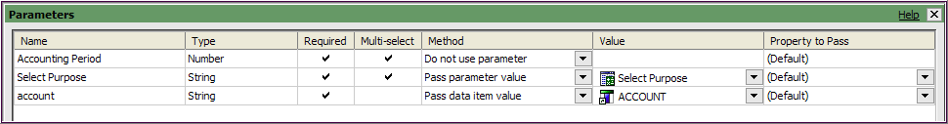

  - Click OK
  - The Drill-Through Definitions window should look like this:

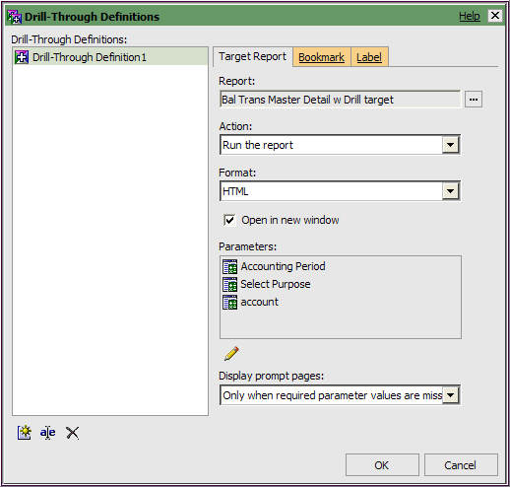

- Click OK

- Save and Run the report
  - Select prompt values for the balance data you want

- In Cognos Viewer, click a “drill” link on one of the Accounts
  - Select your Accounting Period(s) to see the transaction details

Create a Template
You can create a report template to be used for reports specific to your department. To do this, start with a blank report and add the components you want every report to have. Save the report. When you want to use the template, open it, select Save As from the File menu, and re-name the new report.
In this exercise, you will create a report template. When it’s finished it will look like the one below:
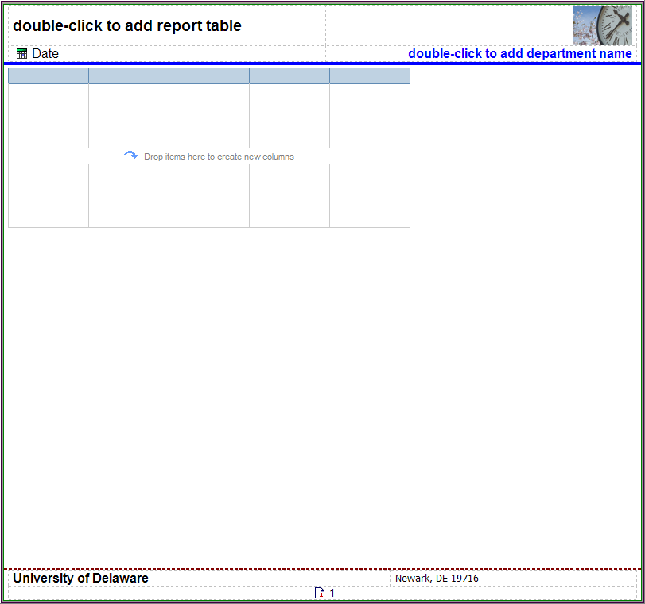
- Open Report Studio using UD Financial Data Mart (in FDM packages)

- Click Create a new report or template

- Select Blank and click OK.
- In the toolbar, click to the Headers & Footers button

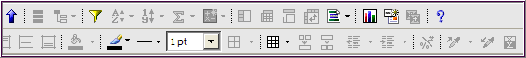

    - Select Page Header & Footer
- Click the boxes next to Header and Footer and click OK.

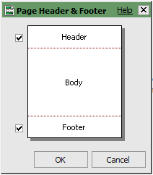
First, we’ll setup the Page Header

- Add a blue line under the header
- Click inside the Page Header area
- In Properties, go to Box/Border and click the ellipses
- Style - select Solid Line
- Width - select 3 pt
- Color - select Blue
- Preview - click the bottom border on the diagram
- Click OK
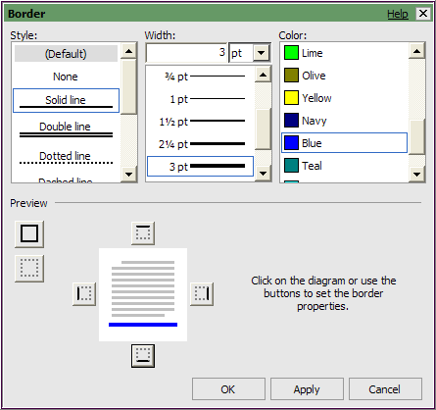
Don’t forget

- Add a table to the header to hold four different elements
- Click the Toolbox tab
- Drag and drop a Table into the Page Header area

- In the Insert Table box:
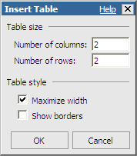

- Type 2 for columns and 2 for rows
- Maximize width box should be checked
- Click OK

- Save this report in My Folders
    - First create a new folder called Templates and open it
    - Name the report Template Example and save it

- Create a placeholder for the report title
  - On the Toolbox tab, drag and drop a Text Item into the top-left table cell
  - In the Text box, type double-click to add a report title
- Click OK

- Change the format of the title placeholder
  - Highlight the text you just added and go to Properties
  - Under the Font & Text/Font, click the ellipses
  - Set the Family to Arial, the Size to 14pt and the Weight to Bold
  - Click OK
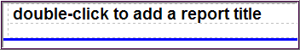

- Add the date to the header and format it
  - From the Toolbox tab, drag and drop Date into the bottom left table cell
  - In the header, highlight the Date and use the Formatting toolbar:
  - Change Font to Arial
  - Change Size to 12pt
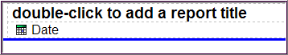

- Save your work

- Create a placeholder for the department name
  - Click the Toolbox tab (if not there already)
  - Drag and drop a Text Item into the bottom-right table cell
  - In the Text box, type double-click to add department name
  - Click OK
- Format the department name placeholder
  - Highlight the text you just added and use the Formatting toolbar:
- Change Font to Arial
- Change Size to 12pt
- Change Foreground Color to Blue
- Click Bold

- Click the background of the bottom-right table cell
  - Use the Formatting toolbar to select Right

- Add an image to the header
  - Open another browser session
  - Go to UD home page (www.udel.edu)

  - Click the button
  - Right-click on one of the thumbnail photos
  - Select Properties
  - Highlight the Address (URL), right-click it and choose Copy
  - Go back to your Cognos report
    - From the Toolbox tab, drag an Image to the upper right cell
    - Click on the Image in the header and go to Properties
    - Under the URL Source/URL, click the ellipses
    - In the Image URL box, right-click and choose Paste
    - Click OK
  - In the header, click the cell around the image and click Right

This completes the Page Header. Your header should look like this:

- Save your work

Now, we’ll add a report “container” to the Page Body

- We’ll add a List to the work area
- Click on the Toolbox tab (if not already there)
- Click List and drag & drop it into the page body
- You will see the familiar List box

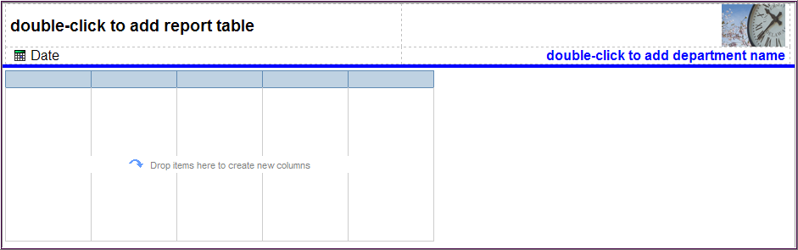

Next, we’ll create the Page Footer

- Add a blue line above the footer area
- In Properties, go to Box/Border, and click the ellipses
- Color - select Blue
- Style - select Solid Line
- Width - select 2pt
- Preview - click the top border on the diagram
- Click OK
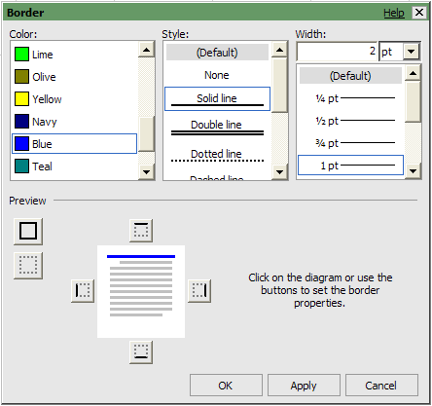
Don’t forget

- Add a table to hold three elements in the footer
- On the Toolbox tab, drag and drop a Table in the Page Footer area

- In the Insert Table box, type 2 for columns and 2 for rows
- Make sure the Maximize width box is checked
- Click OK

- Add text and other fields to the footer:
  - Drag and drop a Text Item into the top-left table cell
  - In the Text box, type University of Delaware
  - Click OK
- Highlight the text you just added and use the Formatting Toolbar:
  - Change Font to Arial,
  - Change Size to 12pt
  - Click Bold

- Drag and drop a Text Item into the top-right table cell
  - In the Text box, type Newark, DE 19716
  - Click OK

- Highlight the text you just added and use the Formatting Toolbar:
  - Change Font to Arial
  - Change Size to 12pt
  - Click Click the background of the same table cell and select Right

- Merge the two bottom table cells to hold the page number
- Click the bottom-left cell, then SHIFT-click the bottom-right cell
- In the toolbar, select Merge Cells

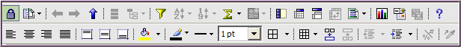

- From the Toolbox tab, click the Page Number and drag it into the bottom table cell
- Highlight the Page Number and use the Formatting Toolbar:
- Change Font to Arial
- Change Size to 10pt
- Click the background of the bottom table cell, select Center

- Save your work

- This completes the Page Footer. Your footer should look like the one below:

Finally, add a color border around the main report area.

- Click the work area and go to Properties
  - Click the Ancestor button and click Page
  - Under Box/Border, click the ellipses
  - Style - select Solid Line
  - Width – select 1px
  - Color - select Green (or any other color)
  - Preview - click all 4 borders of the diagram with this button
  - Click OK
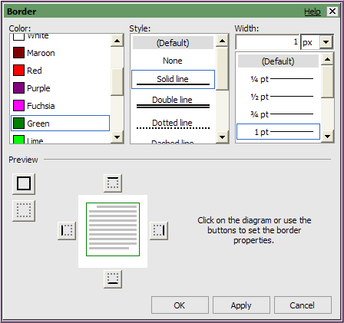
Don’t forget

- Save your work
You have now created a template that can be used to create other reports. When you want to use the template, open it and choose Save As from the File menu. Give the report a new name to preserve the template.

Let’s try it out the new template…

- Save the template with a new name (File/Save As…)
  - Name it Template Example – Trans List

- On the Source tab, open UD Financial Data Mart and add these 10 fields:

Field Name | Query Subject | Folder
CHARTFIELD1 | Trans Detail
FISCAL_YEAR | Trans Detail | Dates
ACCOUNTING_PERIOD | Trans Detail | Dates
ACCOUNT | Chart of Accounts | Account
ACCOUNT_DESCR | Chart of Accounts | Account
ACCOUNTING_DT | Trans Detail
JOURNAL_ID | Trans Detail
JRNL_LN_REF | Trans Detail
TRANS_DESCRIPTION | Trans Detail
TRANS_AMOUNT | Trans Detail

- Add these two pre-written prompts:
  - Purpose Prompt
  - Accounting Period Prompt

- Add these four pre-written filters:
  - ACTUALS Ledger Filter
  - Current Fiscal Year Filter
  - Journal ID not blank Filter
  - Statistics Code not ENP ENU
- Change the header to display your department name
  - Double click the place holder: double-click to add department name
  - Type in your department name and click OK

- Give your report a title
  - Double click the place holder: double-click to add a report title
  - Type - Transactions for [space]
  - Go to the Toolbox tab
  - Drag & drop a Text Item next to the new title

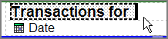

  - Type [space] [space] and click OK
  - Drag & drop a Layout Calculation next to the Text Item

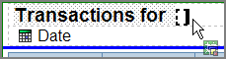

  - In the Report Expression window, click the Parameters tab
  - Double-click Select Purpose and click OK
  - In the header, click on <%PARAMDisplay…%>
    - Change the Font to Arial, 14pt and Bold (on the toolbar)

  - Add the Purpose Description to the title
    - Drag & drop a Text Item next to <%PARAMDisplay…%>

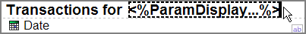

    - Type [space] [space] and click OK
    - Go to the Source tab and find PURPOSE_DESCR
    - Drag & drop it next to the Text Item

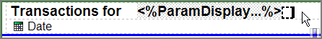

    - You will get a message telling you a Singleton has been created – this is fine – click OK
    - Click on <PURPOSE_DESCR>
      - Change the Font to Arial, 14pt and Bold (on the toolbar)
    - Open Query Explorer from the Explorer Bar; click on Query2
    - From the Source tab, drag & drop the pre-written Purpose Prompt to the Detail Filters pane (upper right)

- Save your work

- Run the report
NOTE - We added the filter, Current Fiscal Year, so choose an appropriate Accounting Period on the 2nd prompt page
Conditional Formatting and Highlighting
You can customize your reports to change how the data is displayed based on conditions you specify. This is done with conditional formatting or highlighting, which allows you to do a number of useful things:

- Show exceptional data within your report based on your criteria
- Emphasize areas of special interest within your report
- Highlight alternate rows in a List report

A. Show exceptional data based on percentage thresholds

You will use an existing report that is based on Balance data and developed for Purposes with budgets. You will add three new calculated fields. The report will compare the percentage of the elapsed fiscal year to the percentage of actual expense to the Purpose budget. Conditional formatting will be added to highlight those Purposes that are over or under budget.

- Open this List report:
  - Go to Public Folder called Ellen Training
  - Open Reports for Class folder
  - Open the report Conditional Exceptional Data
  - IMMEDIATELY Save in My Folders with the same name

- Add a field for the percentage of actual expense to the Purpose budget
  - Go to the Toolbox tab
  - Click and drag a Query Calculation to the right side of the List

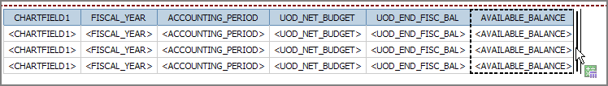

  - Name it Actual to Budget %
  - Create the following expression using two fields from Data Items tab:

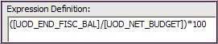
HINT: you will only type:

( / )*100

  - Validate and click OK

- Add a field for the percentage of the elapsed fiscal year
  - Stay in the Toolbox tab
  - Click and drag another Query Calculation to the right side of the List

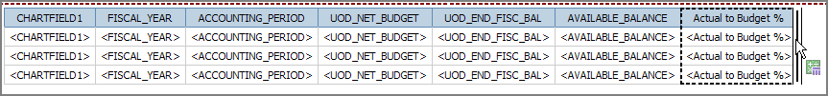

  - Name it Elapsed FY %
  - Create the following CASE WHEN expression:

CASE WHEN ([ACCOUNTING_PERIOD] = 1)
THEN (1/12*100)
WHEN ([ACCOUNTING_PERIOD] = 2)
THEN (2/12*100)
HINT: this expression can be copied from an existing report called CASE WHEN located in Public Folders /Ellen Training/Reports for Class. (Open another instance of Report Studio from the Cognos Welcome page to do this.)

Double-click on the column Elapsed FY % to bring up the Data Item Expression window. Highlight the expression and copy it. Then paste it into new expression box in the first report.
WHEN ([ACCOUNTING_PERIOD] = 3)
THEN (3/12*100)
WHEN ([ACCOUNTING_PERIOD] = 4)
THEN (4/12*100)
WHEN ([ACCOUNTING_PERIOD] = 5)
THEN (5/12*100)
WHEN ([ACCOUNTING_PERIOD] = 6)
THEN (6/12*100)
WHEN ([ACCOUNTING_PERIOD] = 7)
THEN (7/12*100)
WHEN ([ACCOUNTING_PERIOD] = 8)
THEN (8/12*100)
WHEN ([ACCOUNTING_PERIOD] = 9)
THEN (9/12*100)
WHEN ([ACCOUNTING_PERIOD] = 10)
THEN (10/12*100)
WHEN ([ACCOUNTING_PERIOD] = 11)
THEN (11/12*100)
ELSE
(100)
END

  - Validate and click OK

- Add a field for the difference between the two percentage amounts
  - Stay in the Toolbox tab
  - Click and drag another Query Calculation to the right side of the List

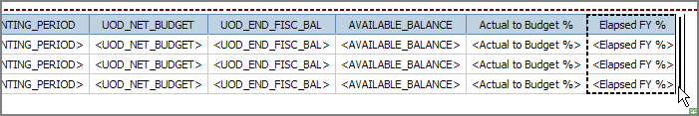

  - Name it Over/Under % Diff
  - Create the following expression using two fields from Data Items tab:

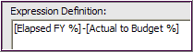
HINT: you will only type:
-

  - Validate and click OK

- Save your work
- Format all the number columns to display 2 decimal points
  - In the work area, right-click on column-body of UOD_NET_BUDGET
  - Choose Style and then Data Format…

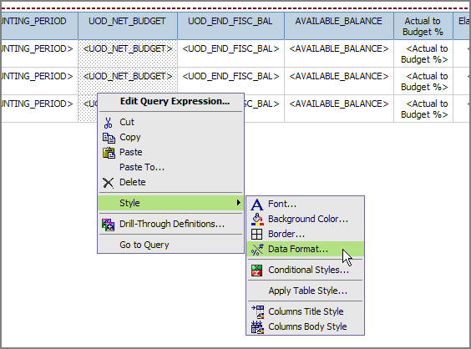

  - In the Data Format window:
    - Format type - select Number and No. of Decimal Places – 2
    - Click OK

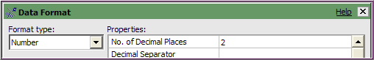

  - With UOD_NET_BUDGET still highlighted, click Pick-up Style

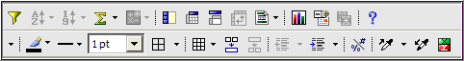

  - Click UOD_END_FISCAL_BAL column-body, then shift-click Over/Under % Diff column-body to highlight all five columns

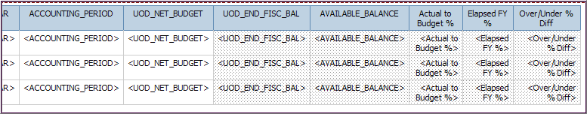

  - Click Apply Style

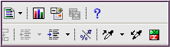

- Save your work

- Create the conditional formatting

You will establish three Styles for three conditions:
- Very Good – for differences over 2%
- Average – for differences between 0 and 2%
- Poor – for differences in the negative

  - Click the Over/Under % Diff column body to highlight it

  - Click the Conditional Styles button on the toolbar

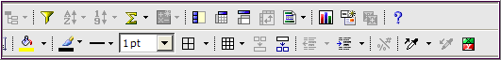

  - Click the New Conditional Styles button

  - Select Advanced Conditional Style…

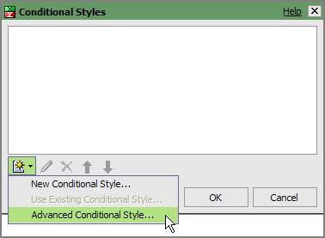

  - Notice there is already a condition Style called (Default)

  - Change the Name to Over/Under Diff

  - Click the New Advanced Condition button” condition to set the “Very good” condition

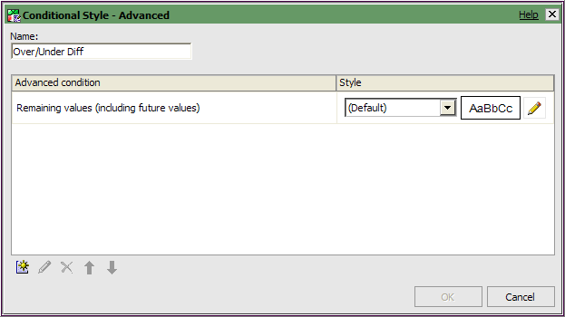

  - Create the following expression that will display any difference over 2% as “very good”
    - Double-click Over/Under % Diff
    - Then type >=2

  - Validate and click OK

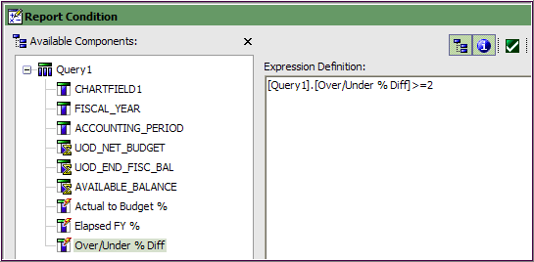

  - Style – click the dropdown and select Very Good for the new condition

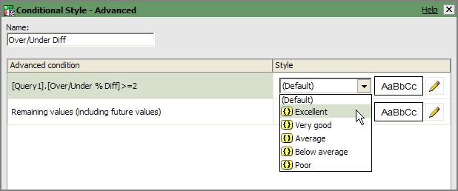

  - Notice the Style has changed to green letters with a white background:

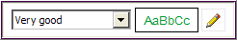
Note: The Style can be customized using the Edit button

  - Click New Advanced Condition to set the “Average” condition

  - Create the following expression that will display any difference between 0 and 2% as “average”
    - In Available Components, double-click Over/Under % Diff
    - Then type between 0 and 2

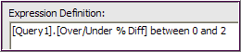
  - Style – click the dropdown and select Average

  - Notice the Style has changed to gold letters with a white background

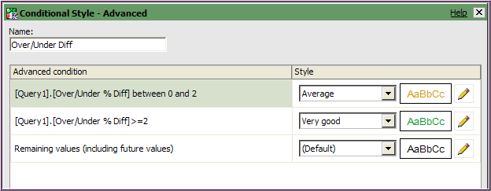
________________________________________________________

  - The Advanced condition called Remaining Values (including future values) will be used for the last condition
    - Looking at the two new conditions, we can deduce the “Remaining values” means anything less than 0 or negative amounts

  - Style – click the dropdown and select “Poor”
    - Note the Style is white lettering with a red background

  - Click OK and click OK again

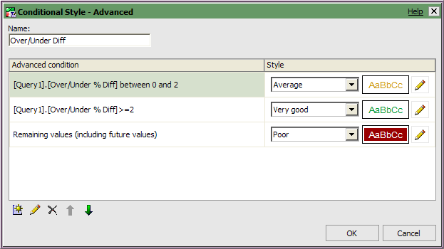

- Save your work

- Run the report with multiple “11” (Basic Budget) Purpose codes

Looking at your report results, you may notice that some of your Purpose codes do not have budgets and should not be included in your report. The next step will eliminate those Purposes.

- Add a filter to restrict results to active Purposes with budgets
  - Click Filter on the toolbar
  - Click Add
  - Create the Expression using the Data Items tab:

[UOD_NET_BUDGET]>0

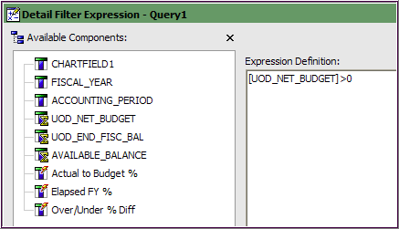

  - Validate and click OK

Hint – Fields with icons like this have been auto-aggregated (summed). When using fields like this in a Filter, you will want to change the Application setting to After auto aggregation.

  - VERY IMPORTANT – With the new filter highlighted, click After auto aggregation in the Application settings

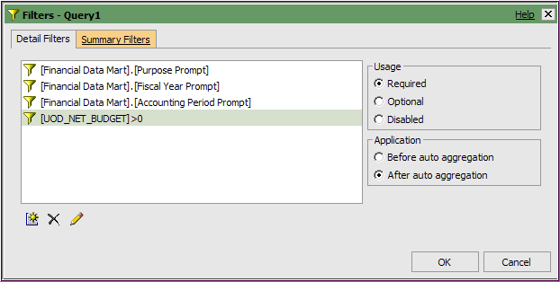

  - Click OK

- Save your work
- Run the report
- (*Optional*) Add a key to the top of the report for the conditional formatting
  - Go to the Toolbox
  - Drag and drop a Table under the title
  - The Table will have 2 Columns and 3 Rows
  - You will add Text Items to all the cells to look like below:

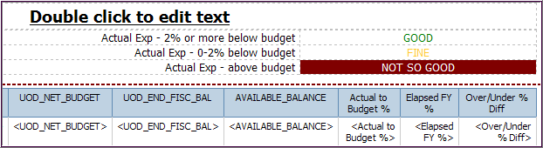

  - Use the Foreground Color and Background Color buttons on the toolbar to set the words GOOD, FINE and NOT SO GOOD to the correct colors
(Hint - Consider using the Web Safe Colors tab to find more accurate colors.)
  - Save your work and Run the report

B. Add alternating colors for rows of a List using a conditional variable
- Open this report in the Public Folder called Ellen Training:
  - Conditional Alternating Rows
  - IMMEDIATELY Save in My Folders with the same name

- Add a calculated data item to give even rows the value of 0 and odd rows the value of 1
  - Click the Toolbox tab
  - Click and drop a Query Calculation to be the first column on the left

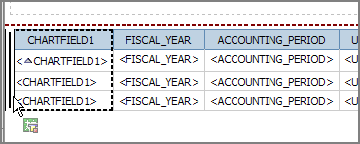

  - Name it EvenOdd
  - Create this expression:
Note: This expression uses the Mod function to calculate a remainder to give each row in the report a value of either 1 or 0.

It takes the running count of CHARTFIELD1 (1,2,3,4...) and divides by 2. The result will be either 1 or 0.

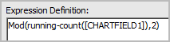

  - Validate the expression and click OK twice
- Run the report for multiple Purpose codes
  - Notice that the even rows have the value of 0 and odd ones are 1
  - These values will be used for the conditional formatting but do not belong in the report
  - Close Cognos Viewer

- EvenOdd needs to become a property of the list
  - Click the EvenOdd column in the report and click CUT (not delete)
  - Click anywhere on the list and go to Properties
  - Click the Ancestor button and select List

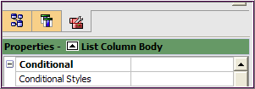

  - Double click Data/Properties, select EvenOdd checkbox and click OK

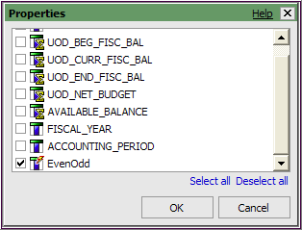

- Create a Boolean variable based on the value of EvenOdd
  - Open the Condition Explorer and click Variables

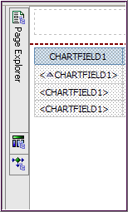
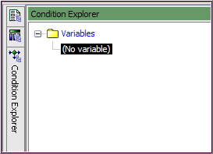

  - In the Insertable Objects, double-click Boolean Variable

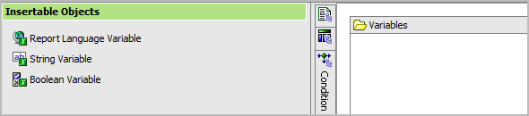

  - In Available Components, double-click EvenOdd to add it to the Expression box
  - Type =0, your expression should look like this

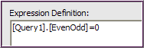

  - Validate and click OK
  - The Condition Explorer work area will look like this:

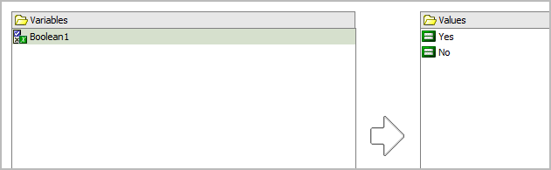

  - With the Boolean1 variable still highlighted, go to Properties
    - In Miscellaneous/Name - change the name to EvenRows

- Apply the conditional formatting
  - Open Page Explorer and click on Page1
  - Click anywhere on the List and go to Properties
    - Click the Ancestor button and select List Columns Body Style

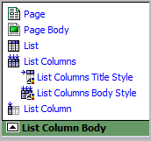

    - Go to Conditional/Style Variable, click the Ellipses
    - Choose EvenRows from the dropdown list

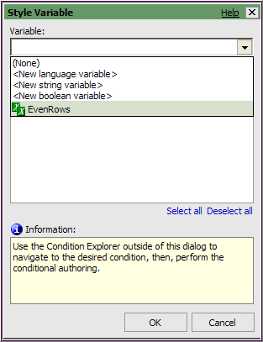

    - The Style Variable window will change to look like below
    - Click OK

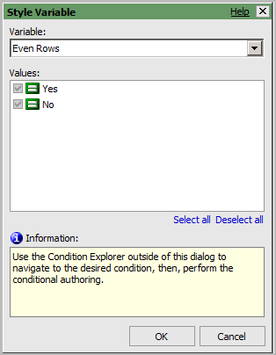

  - Open Conditional Explorer and click Yes

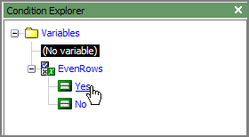

    - The Explorer Bar turns green to indicate that conditional formatting is turned ON

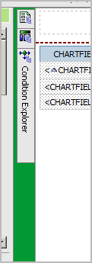

  - On the toolbar, click Background Color

    - Click the tab called Web Safe Colors

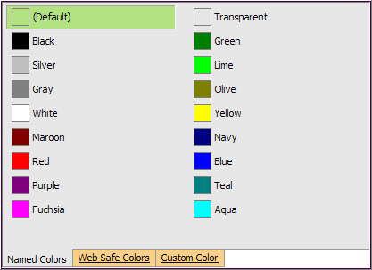

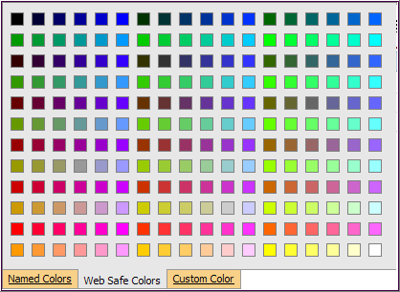

    - Click a suitable color such as a light blue, light green or lavender
    - Click OK

  - The list column are highlighted in blue (or green or whatever you chose)
  - Double-click the Explorer Bar to turn OFF conditional formatting
    - It should be green
    - The Explorer Bar will change color from green to grey

- Save your work
- Run the report

