Higher Education Consortia

News and Updates: 2017 Delaware Cost Study

October 2017

Hope you have had an opportunity to check out the Direct Instructional Expenditure by Program Chart now available on the Web Portal for our participating institutions.

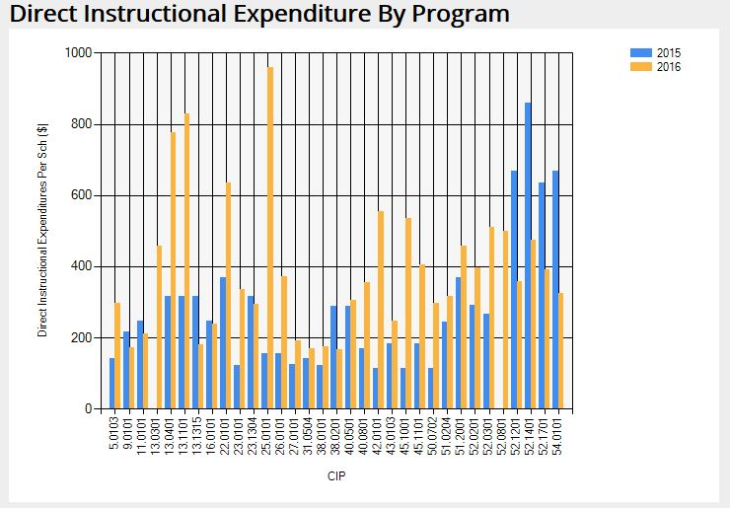



The Early Registration Discount is no longer available, but there is still time to register for the 2017 Delaware Cost Study. We will be accepting registrations thru the New Year. Please go to our website and click on the ‘Registration and Payment Option’ to participate this year! Hope to hear from you soon.



Coming Soon to the Web Portal – We will be introducing more Three Year Averages by Carnegie Classification. We are in the process of producing 3-year averages for the totals in Table 3 of your Institutional Report. For example, you will be able to compare your undergraduate SCH per FTE faculty with the 3–year average undergraduate SCH/FTE of participating institutions by Carnegie Classification.

These averages will first be available on page two of the Web Portal program input pages and then, once the data has been verified by our office, there will be additional columns in your Institutional Report,. You will have comparisons by program at your fingertips as soon as your data has been inputted into the Web Portal.





One way to use the data from the Delaware Cost Study: This chart is one example of how you can use the National Norms from the Delaware Cost Study. Here we are comparing ‘The University of Example’s’ data to see if they compare to the norm when looking at the number of SCH taught by different faculty types. From this chart, we see in Computer & Information Sciences, that perhaps they could effectively teach more students by utilizing Teaching Assistants and other Regular Faculty.

If you are interested in how to re-create this chart, please let us know at [ire-cost@udel.edu](mailto:ire-cost@udel.edu). We would be happy to arrange a webinar demonstrating the process.



**FYI** – Institutional Reports and the National Norms are now available in a .txt file if needed. Please contact our office at [ire-cost@udel.edu](mailto:ire-cost@udel.edu) for additional information.



**Reminder: Advanced Analysis of the Delaware Cost Study Results**

The Cost Study team is exploring innovative uses of our data beyond simply comparing individual program’s cost per student credit hour with national norms. Our current goal has two-fold: first, peer group selection is critical for benchmarking as it determines whom you compare yourself to. One of our research projects developed a refined peer selection approach to allow participants to identify their discipline-level peers for more accurate, data-informed program evaluation.

Second, institutional leadership and department chairs need measurable goals when benchmarking instructional productivities and expenditures. Using a data envelopment analysis (DEA) approach, we benchmark individual programs with their most efficient peers at the disciplinary level in terms of their allocation of faculty resources and instructional costs. For each program, DEA yields an efficiency number indicating its distance from its most efficient peers and a data-driven optimal solution.

The preliminary results of the above research were presented at Association of Institutional Research Annual Conference 2017, Washington, DC (<http://forum.airweb.org/2016/pages/forum-sessions>). More updated work will be shared in workshops and speaker sessions at regional IR annul conferences this fall, including SAIR 2017 (<http://www.louisianau.com/sair17/> ), CIRPA 2017 (https://cirpa-acpri.ca/) , CAIR 2017 (<http://www.cair.org/conferences/annual-conference/>) and NEAIR 2017 (<https://www.neair.org/2017_conference_program.php>).

Please contact Ti Yan at [yant@udel.edu](mailto:yant@udel.edu) or Tom Eleuterio at [tommyu@udel.edu](mailto:tommyu@udel.edu) for more information.